

Dr. David, Hill inc.

2016-06-25

Dr. Hill

53662 Michael Ports, New Kevinhaven, NE 62346

Phone: 8408806659

Fax: 5720445227

**Re:** Jessica, Holmes

**PHN:** 3402835272

**Birthdate:** 18-Aug-1950

**Address:** 61885 Hunt Landing, Dianefurt, NV 49201

**Patient number:** 8286242809

To Whom It May Concern:

This is a medical letter to state the above patient is pregnant with expected delivery date of 25-Aug-2025. Hoping this information is satisfactory for your requirements.

Thank you.

Sincerely,

Dr. David, Hill

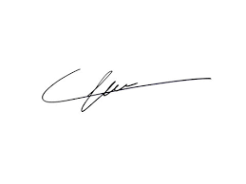

FRCS© NCMP

Clinical Assistant Professor, UBC

Department of Obstetrics and Gynecology SMH